**Benha University (3th year – Communication and Computer )**

**Faculty of Engineering *Transmission Line* (E1312)**

**Electrical Engineering Department 2st term 2015- 2016**

**Dr. Abdelhady Mahmoud**

Final Written Examination. Time all: 3 hrs.

5 June 2016

***Answer all questions***

***Question One:* [15 points]**

**(a) Derives Maxwell’s equations for free space media.**  (5 points)

(b) **Let *jk* = 0.2+*j*1.5 m-1 and *η* = 450+ *j*60 Ω for a uniform plane** (10 points)

**propagating in the az direction. If ω= 300 Mrad /sec, find *μ* , *ϵ΄*, and *ϵ΄΄* for the medium.**

***Question Two:*  [15 points]**

**A 10 GHz radar signal may be represented as a uniform plane wave in a sufficiently small region. Calculate the wavelength in centimeters and the attenuation in nepers per meter if the wave is propagating in a non-magnetic material for which:**

a) and  (5 points)

b) and  (5 points)

c) and  (5 points)

***Question Three:*  [15 points]**

**Region 1 , z < 0, and region 2, z > 0, are described by the following parameters:**

***p*F/m, *μ*H/m, , *p*F/m , *μ*H/m and .**

**If ax V/m,**

**find:**

**(a) α1  (b) β1 (c)  (d)  (e) **

***Question Four*: [10 points]**

**The propagation constant of a lossy transmission line is 1 + *j* 2 m-1 and its characteristic impedance is 20 + *j* 0 Ω at ω = 1 Mrad/sec. Find: L,C,R, and G for the line.**

**Please turn the page**

***Question Five:*  [15 points]**

**Let transmission line terminated by ZL = 40 - *j* 10 Ω, has Zo = 50 Ω , operates at *f* = 800 MHz and *v* = *c*.**

**Find:**

**a) Reflection coefficient at load. (**3 points**)**

**b) Standing wave ratio at load.** (3 points**)**

**c) Location of first maximum and first minimum from load (per wavelength).** (3 points**)**

**d) The shortest length d1 of a short stub and transmission line d for matching with Zo.**

**(**3 points**)**

**e) The shortest length d1 of an open stub and transmission line d for matching with Zo.**

**(**3 points**)**

***Question Six:*  [20 points]**

**In Fig. I, there no initial voltage before switch is on. The transmission line is terminated by RL = 25** Ω **while the generator has Rg = 25** Ω**. The line has Zo = 50** Ω

**for the time period 0 < t < 4*l*/*v* , plot**

**a) Voltage and current reflection diagram as function of Vo. (**5 points**)**

**b) The line voltage at 3*l*/4 as function of Vo. (**5 points**)**

**c) The line current at 3*l*/4 as function of Vo.** (5 points**)**

**d) The steady state voltage and current as function of Vo. (**5 points**)**

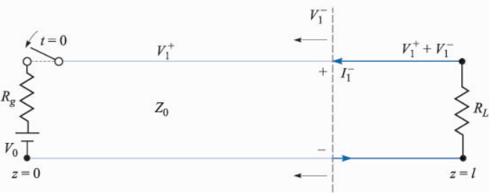

**Fig. I**

**With my best wishes**